Questionnaire for the bulk product volume and average level
measuring systems.
Customer contact details:
Organization name | _{Company name}
Contact person | _{Enter the person’s name.}
Position | _{Specify your position}
E-mail | _{Enter the email.}
Phone | _{Enter the phone.}
Adress of the object | _{Enter the adress.}
Number of vessels | _{Enter the number}
Information about the product to be measured:
Name | _{Enter the name.}
Angle of repose ° | _{Enter the angle.}
Requirements for explosion protection certificates:
No ☐ | Ex ta IIIC T₂₀₀ 100 Da ☐ | Ex d IIB T6 Gb ☐ | Other: _{Enter the designation}
Temperature in the level gauge installation area:
Min. | _{min temperature} | °C
Max | _{max temperature} | °C
Vessel pressure:
Atmospheric | ☐
Min. | _{Enter the pressure}
Max | _{Enter the pressure}
Estimated composition of the system:
Unknown | ☐
ULM-3D-1 | _{Quantity per vessel}
ULM-3D-5 | _{Quantity per vessel}
ULM-3D-64 | _{Quantity per vessel}
Acceptable measurement error:
<0.5% ☐ | <1.0% ☐ | <3.0% ☐ | <5.0% ☐ | <10.0% ☐
Other: _{Specify max error}
The error is indicated in % of the volume of the vessel
Tank type and dimensions:
Circular section or similar ☐
A | m
B | m
C | m
D | m
E | m
F | m
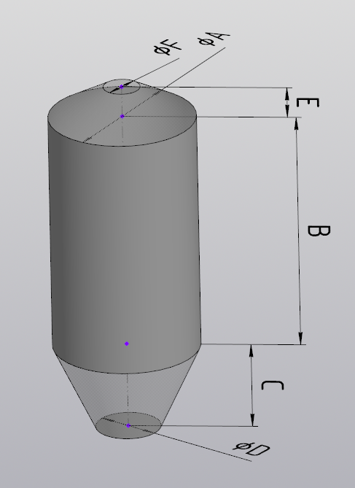
A | m
B | m
C | m
D | m
E | m
F | m
G | m
H | m
I | m
Rectangular section or similar ☐
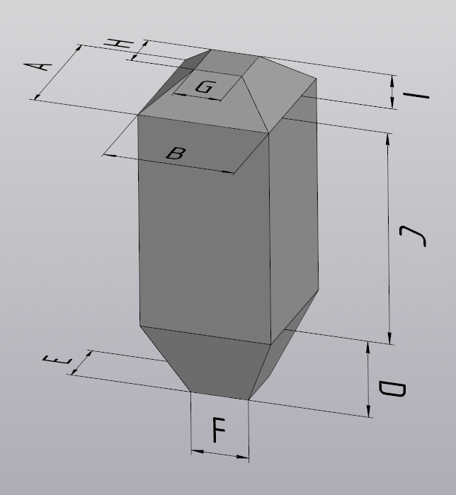

Main differences between the actual tank and the above markedoption:
Describe the main differences between the tank and the standard shape (selected above), if any. If the differences are significant, attach drawings and/or sketches and/or photos indicating the differences or showing the entire tank with the main dimensions.
Detailed information:
Roof:
- It is necessary to attach the roof drawings or sketches (see example below) indicating the following:
- places specified for the level transmitter installation (if any)
- areas allowed for the level transmitter installation
- areas prohibited for the level transmitter installation
- places of backfill\filling with dimensions
- metal structures above and under the roof, indicating the dimensions and location.
- Specify the roof thickness (without metal structures, etc.) m.
- Attach photos (if available)
Tank body:
- If there are protruding structures (stairs, stiffeners, etc.) inside the tank, attach drawings and/or sketches and/or photos indicating the structure position and dimensions
Lower part of the tank:
- It is necessary to attach drawings and/or sketches and/or photos of the lower part indicating the following:
- protruding structures (dividers, gates, stiffeners, etc.) with dimensions
- places of unloading/pouring with dimensions

Examples of attachment:
Example 1: rectangular tank roof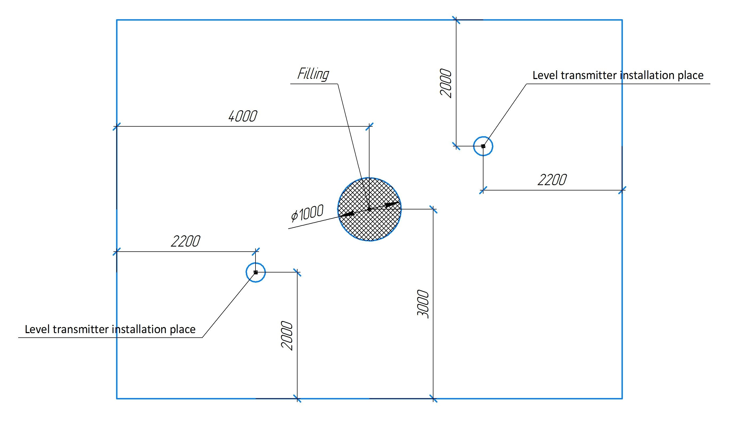
Example 2: circular tank roof 